**Facebook – mini**

Made by students of IS-71:

Prydorozhko Artem & Sotnikov Vitalij

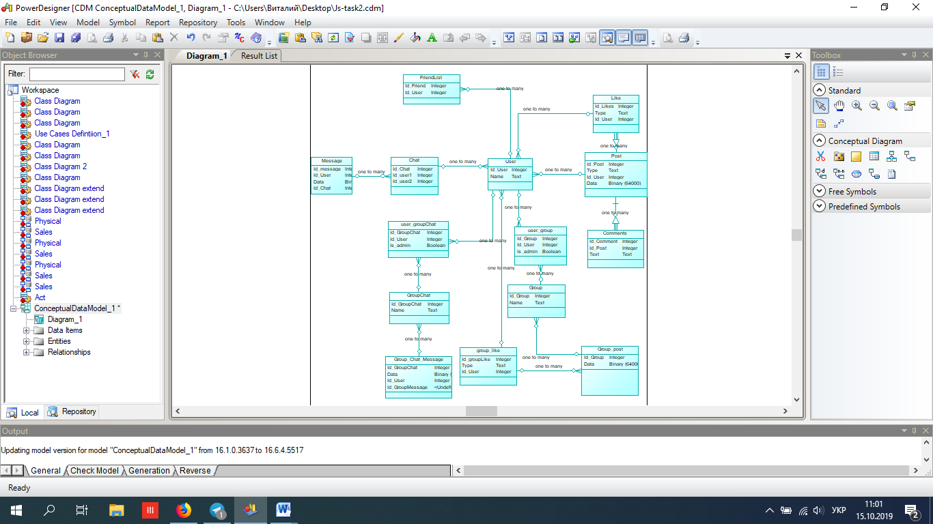

user/group

created

edited

deleted

message

deleted

edited

created

post

created

deleted

liked

edited